**Store Admin User Manual for**

**E-commerce**

|  |  |
| --- | --- |
| **No** | **Topic** |
| 1 | Introduction |
| 2 | User Authentication |
| 3 | Managing Product |
| 4 | Managing Orders |
| 5 | Managing Customers |
| 6 | Settings |
| 7 | Logout |

**1. Introduction**

Welcome to the Admin User Manual for the E-commerce Project! This manual is designed to guide you through the various functionalities available to an admin within the system. As an admin, you have access to managing products, orders, customers, categories, discounts, reports, settings, and more.

**2. Logging into the System**

* Open your web browser and visit the e-commerce website.
* Click on the 'Login' or 'Sign In' button.
* Enter your registered email address and password.
* Click on 'Login' to access your account.

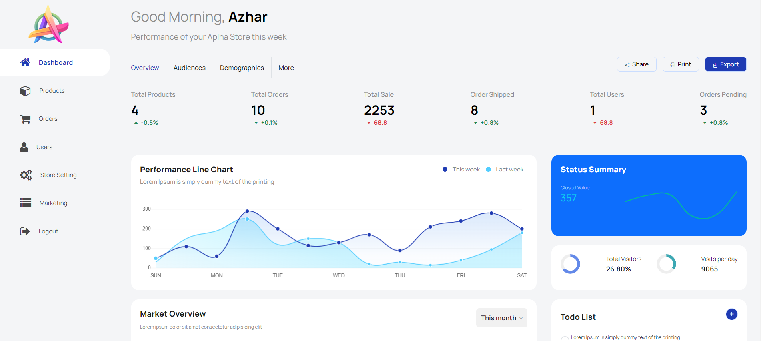

**3. Managing Products**

**Adding Products**

* Navigate to the 'Products' section on the dashboard.
* Click on 'Add Product'.
* Fill in the product details such as name, description, price, images, etc.
* Set the product's relevant information.
* Click on 'Save' to add the product.

**Editing Products**

* Go to the 'Products' section and find the product you want to edit.
* Click on the 'Edit' button next to the product.
* Modify the necessary details.
* Click on 'Update' to save the changes.

**Deleting Products**

* In the 'Products' section, select the product you wish to delete.
* Click on the 'Delete' button.
* Confirm the action to remove the product from the system.

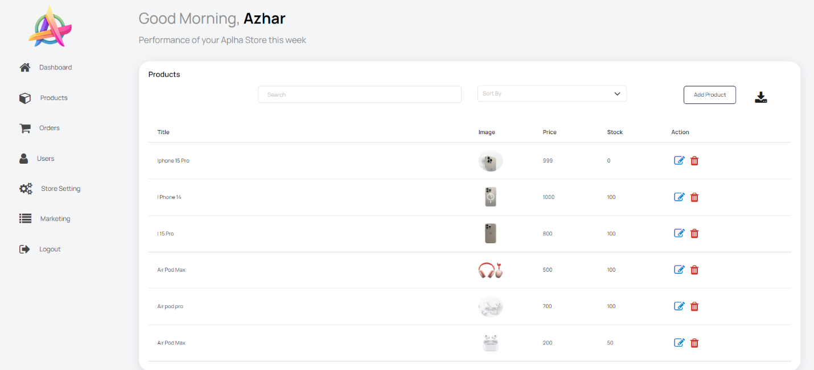

**4. Managing Orders**

**Viewing Orders**

* Visit the 'Orders' section from the dashboard.
* View a list of recent orders with details like order ID, customer details, items
* purchased, etc.

**Updating Order Status**

* Select an order to update its status.
* Change the order status based on processing, shipped, delivered, etc.
* Save the changes to update the order status.

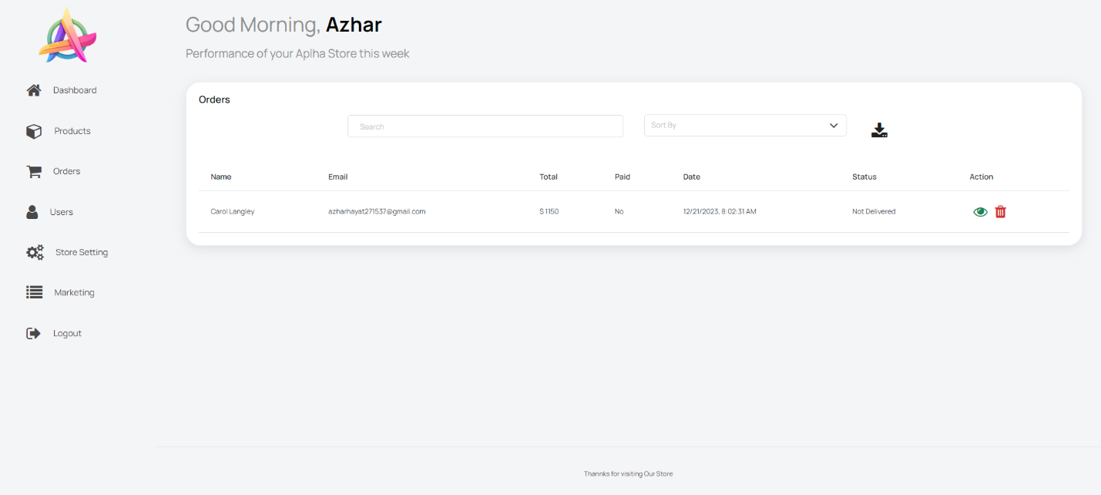

**5.Managing Customers**

**Viewing Customer Information**

* Access the 'Customers' section in the dashboard.
* View a list of registered customers along with their details.

**Managing Customer Accounts**

* Find the customer account you want to manage.
* Perform actions like editing account information, updating details, or deactivating
* accounts if necessary.

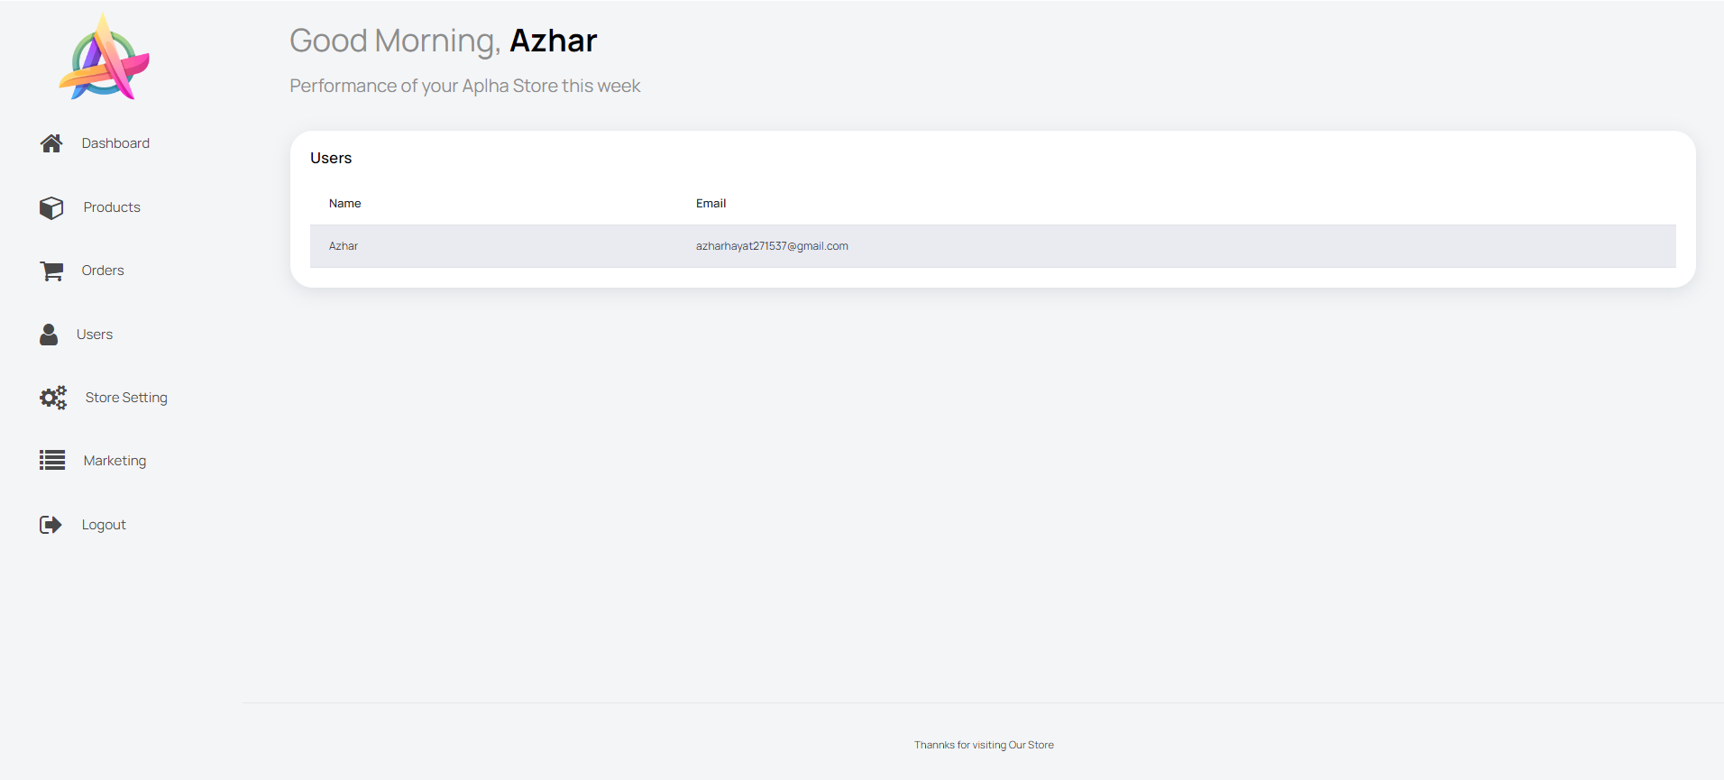

**6. Settings and Configuration**

**General Settings**

* Modify general settings like site name, logo, contact information, etc.

**Payment and Shipping Settings**

* Configure payment gateways, shipping methods, and related settings.

**Security Settings**

* Ensure security measures like account access controls, password policies, etc., are appropriately configured.

**7. Logout**

To log out of the admin panel, click on the 'Logout' button in the dashboard.

**Store Customer User Manual for**

**E-commerce**

|  |  |
| --- | --- |
| **No** | **Topic** |
| 1 | Introduction |
| 2 | User Authentication |
| 3 | Browsing and Searching Products |
| 4 | Viewing Products Detail |
| 5 | Adding Products to Cart |
| 6 | Checkout Process |
| 7 | Payment and Order Confirmation |
| 8 | Managing Account Information |
| 9 | Logout |

**1. Introduction**

Welcome to the Customer User Manual for the E-commerce Project! This manual will

guide you through the steps to navigate, search for products, and make purchases on

the platform.

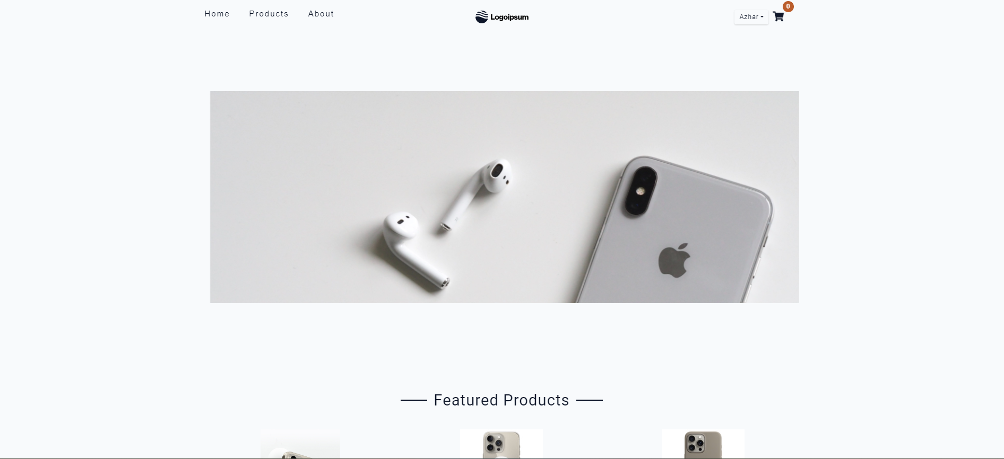

**2. Logging into the System**

* Open your web browser and visit the e-commerce website.
* Click on the 'Login' or 'Sign In' button.
* Enter your registered email address and password.
* Click on 'Login' to access your account.

**3. Browsing and Searching for Products**

**Browsing Categories**

* On the homepage or navigation bar, explore different product categories (e.g.,

electronics, clothing, accessories).

* Click on a category to view available products within that category.

**Searching for Products**

* Utilize the search bar located on the website to search for specific products.
* Enter keywords related to the product you are looking for and press 'Enter' or

click the 'Search' button.

**4. Viewing Product Details**

* Click on a product image or title to view its detailed description, price, images,

specifications, etc.

* Read through the product details to ensure it meets your requirements.

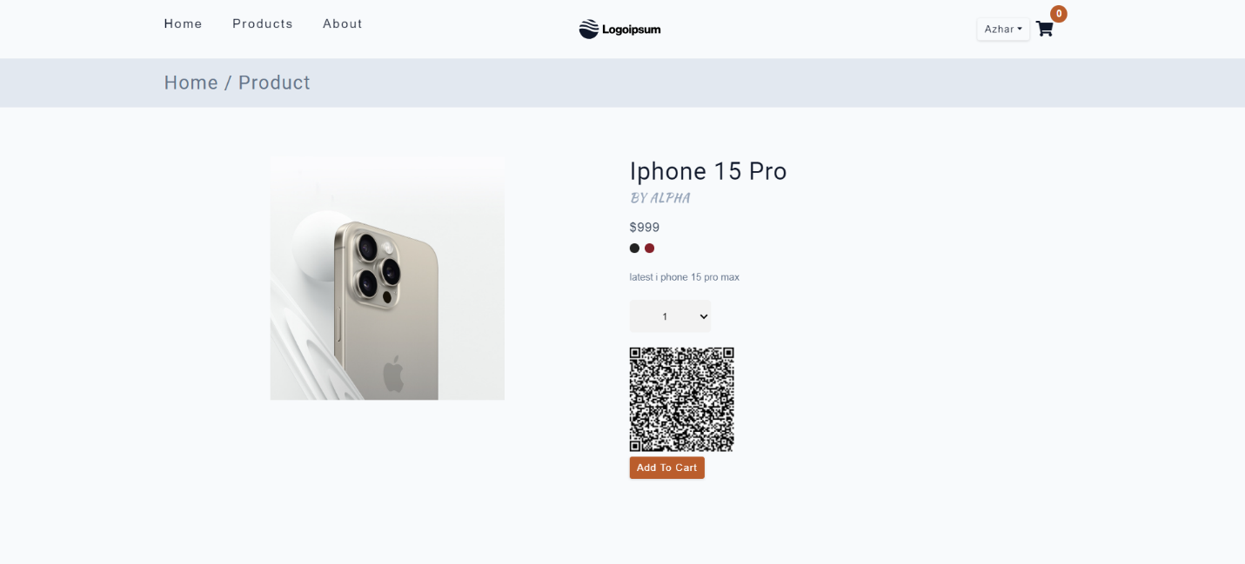

**5. Adding Products to Cart**

* Once you've decided to purchase a product, click on the 'Add to Cart' or 'Buy

Now' button.

* The product will be added to your shopping cart.

**6. Checkout Process**

**Viewing Shopping Cart**

* Click on the shopping cart icon or navigate to the 'Cart' or 'Checkout' section.
* Review the items in your cart, update quantities, or remove products if necessary.

**Proceeding to Checkout**

* Click on the 'Checkout' button to proceed with your purchase.
* Enter the shipping address, contact information, and any additional required

details.

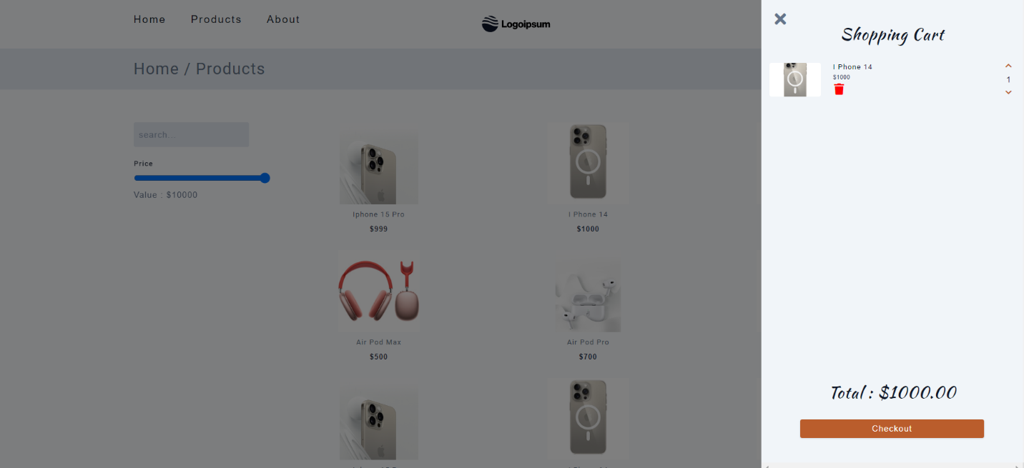

**7. Payment and Order Confirmation**

**Selecting Payment Method**

* Choose a preferred payment method (e.g., credit/debit card, PayPal, etc.).
* Enter payment details securely.

**Confirming Order**

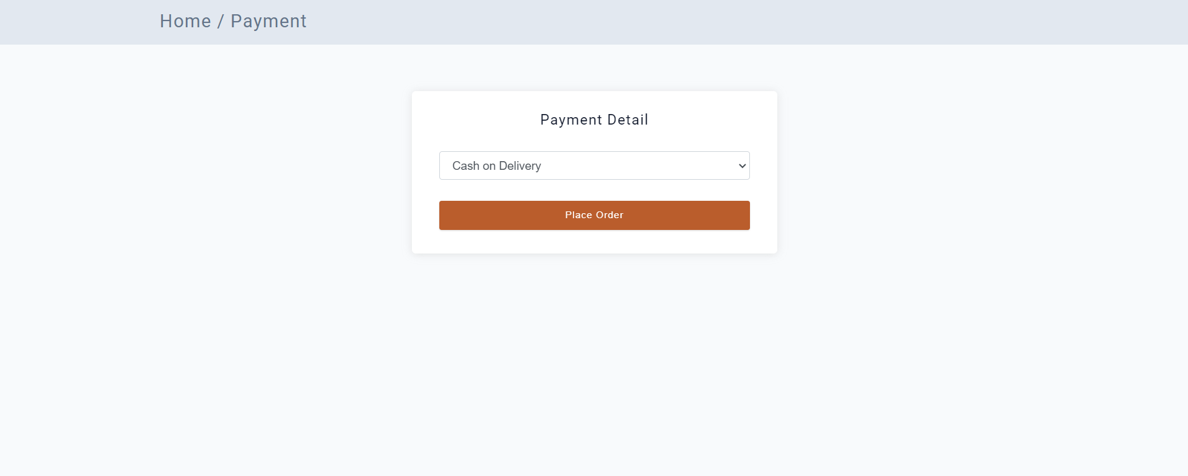

**8. Managing Account Information**

**Updating Account Details**

* Click on your profile or account icon.
* Navigate to 'Account Settings' or 'My Profile.'
* Update personal information, addresses, passwords, etc., if needed.

**9. Logout**

To log out of your account, click on the 'Logout' or 'Sign Out' button located in your

profile/account section.